Introduction

Responsive Web Design
The Internet took off quicker than anyone would have predicted, growing like crazy. Now, for the past few years, mobile growth has exploded onto the scene. The growth of mobile Internet usage is also far out pacing that of general Internet usage growth.
These days it is hard to find someone who doesn’t own a mobile device, or multiple, connected to the Internet. In the UK there are more mobile phones than people, and should trends continue mobile Internet usage will surpass that of desktop Internet usage within the year.
With the growth in mobile Internet usage comes the question of how to build websites suitable for all users. The industry response to this question has become responsive web design, also known as RWD.

Responsive Overview
Responsive web design is the practice of building a website suitable to work on every device and every screen size, no matter how large or small, mobile or desktop. Responsive web design is focused around providing an intuitive and gratifying experience for everyone. Desktop computer and cell phone users alike all benefit from responsive websites.The responsive web design term itself was coined, and largely developed, by Ethan Marcotte.
HTML
Hypertext Markup Language (HTML) is the standard markup language for documents designed to be displayed in a web browser. It can be assisted by technologies such as Cascading Style Sheets (CSS) and scripting languages such as JavaScript. HTML elements are the building blocks of HTML pages. With HTML constructs, images and other objects such as interactive forms may be embedded into the rendered page. HTML provides a means to create structured documents by denoting structural semantics for text such as headings, paragraphs, lists, links, quotes and other items. HTML elements are delineated by tags, written using angle brackets. Tags such as <img /> and <input /> directly introduce content into the page. Other tags such as <p> surround and provide information about document text and may include other tags as sub-elements. Browsers do not display the HTML tags, but use them to interpret the content of the page.
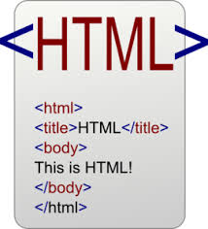
CSS
Cascading Style Sheets (CSS) is a style sheet language used for describing the presentation of a document written in a markup language like HTML. CSS is a cornerstone technology of the World Wide Web, alongside HTML and JavaScript.
CSS is designed to enable the separation of presentation and content, including layout, colors, and fonts.This separation can improve content accessibility, provide more flexibility and control in the specification of presentation characteristics, enable multiple web pages to share formatting by specifying the relevant CSS in a separate .css file, and reduce complexity and repetition in the structural content.
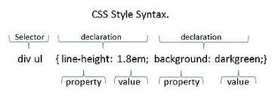
Bootstrap
Bootstrap is a free and open-source framework for creating websites and web applications. It's the most popular HTML, CSS, and JS framework for developing responsive, mobile first projects on the web. As the web evolves more and more toward responsive design, it can be a real challenge for web developers to keep up. Bootstrap can make things a whole lot easier. Bootstrap enables you to create responsive websites without you needing to do the "responsive" bit. Bootstrap takes care of that.
Bootstrap Components
Bootstap includes components such as buttons, navbars, dropdown menus, alert boxes, and more. In most cases, you can make use of a component simply by using the appropriate class name.We'll be looking at these components throughout this tutorial. We've got plenty of interactive examples that enable you to see exactly how these components work.
Advantages of Bootstrap
One of the main benefits of development frameworks like Bootstrap is that they can help speed up development times, while maintaining quality and consistency across the site. You no longer need to re-design every element. And you don't need to spend hours trying to get everything looking and working right across browsers, platforms, and devices. By using Bootstrap, all (most) of the hard work is one for you.Given Bootstrap is the most popular frontend development framework on the web, this skillset could be a useful one to learn. Adding Bootstrap to your bag of tricks could help you in many ways — from building websites faster, to landing your dream job.


Responsive meta tag
Bootstrap is developed mobile first, a strategy in which we optimize code for mobile devices first and then scale up components as necessary using CSS media queries. To ensure proper rendering and touch zooming for all devices, add the responsive viewport meta tag to your <head>.
<meta name="viewport" content="width=device-width, initial-scale=1, shrink-to-fit=no">
You can see an example of this in action in the starter template.
Box-sizing
For more straightforward sizing in CSS, we switch the global box-sizing value from content-box to border-box. This ensures padding does not affect the final computed width of an element, but it can cause problems with some third party software like Google Maps and Google Custom Search Engine.
On the rare occasion you need to override it, use something like the following:
.selector-for-some-widget {
box-sizing: content-box;}
With the above snippet, nested elements—including generated content via ::before and ::after—will all inherit the specified box-sizing for that .selector-for-some-widget.

Responsive vs. Adaptive vs. Mobile
For some the term responsive may not be new, and others might be even more acquainted with the terms adaptive or mobile. Which may leave you wondering what exactly is the difference between all of them.
Responsive and adaptive web design are closely related, and often transposed as one in the same. Responsive generally means to react quickly and positively to any change, while adaptive means to be easily modified for a new purpose or situation, such as change. With responsive design websites continually and fluidly change based on different factors, such as viewport width, while adaptive websites are built to a group of preset factors. A combination of the two is ideal, providing the perfect formula for functional websites. Which term is used specifically doesn’t make a huge difference.
Mobile, on the other hand, generally means to build a separate website commonly on a new domain solely for mobile users. While this does occasionally have its place, it normally isn’t a great idea. Mobile websites can be extremely light but they do come with the dependencies of a new code base and browser sniffing, all of which can become an obstacle for both developers and users. Currently the most popular technique lies within responsive web design, favoring design that dynamically adapts to different browser and device viewports, changing layout and content along the way. This solution has the benefits of being all three, responsive, adaptive, and mobile.

Flexible Layouts
Responsive web design is broken down into three main components, including flexible layouts, media queries, and flexible media. The first part, flexible layouts, is the practice of building the layout of a website with a flexible grid, capable of dynamically resizing to any width. Flexible grids are built using relative length units, most commonly percentages or em units. These relative lengths are then used to declare common grid property values such as width, margin, or padding.
Flexible layouts do not advocate the use of fixed measurement units, such as pixels or inches. Reason being, the viewport height and width continually change from device to device. Website layouts need to adapt to this change and fixed values have too many constraints. Fortunately, Ethan pointed out an easy formula to help identify the proportions of a flexible layout using relative values.
The formula is based around taking the target width of an element and dividing it by the width of it’s parent element. The result is the relative width of the target element.
target ÷ context = result

Flexible Grid
Let’s see how this formula works inside of a two column layout. Below we have a parent division with the class of container wrapping both the section and aside elements. The goal is to have have the section on the left and the aside on the right, with equal margins between the two. Normally the markup and styles for this layout would look a bit like the following.

HTML
1  2  3  4  5 | <div class="container">  <section>...</section>  <aside>...</aside></div>

CSS
1  2  3  4  5  6  7  8  9  10  11  12  13  14  15  16 | .container {  width: 538px;}  section,aside {  margin: 10px;}  section {  float: left;  width: 340px;}  aside {  float: right;  width: 158px;  }

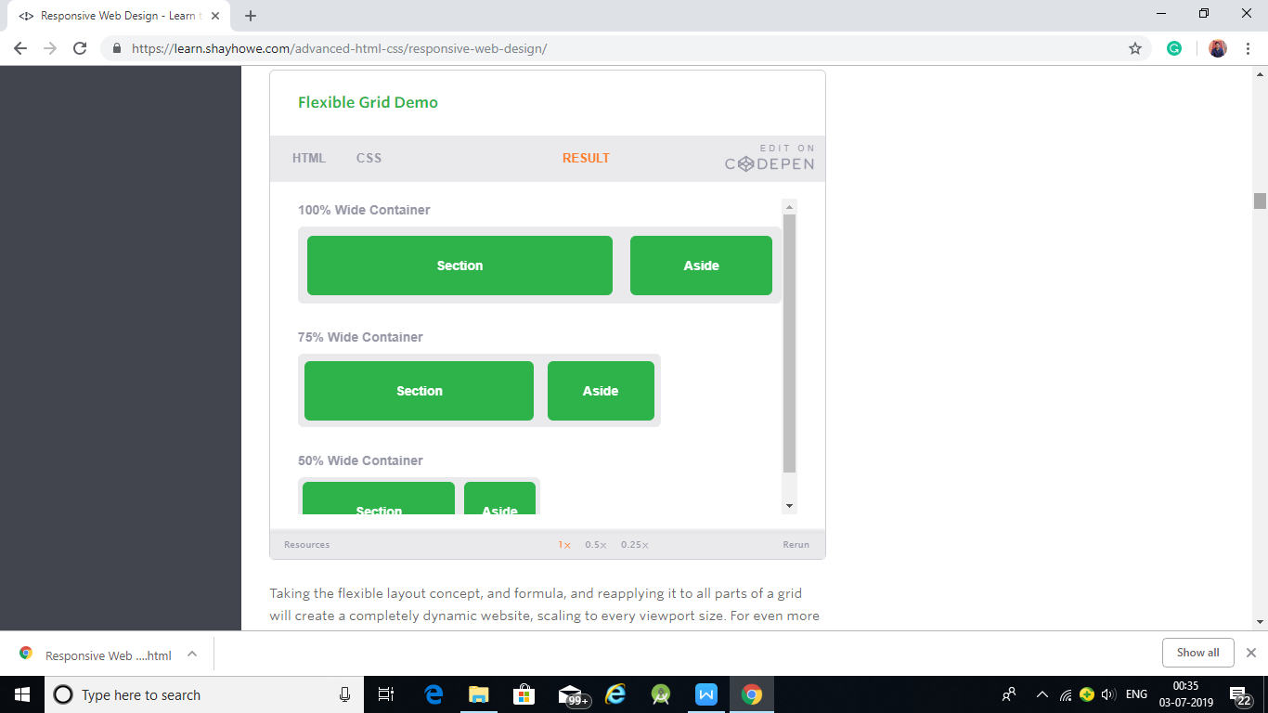

Media Queries
Media queries were built as an extension to media types commonly found when targeting and including styles. Media queries provide the ability to specify different styles for individual browser and device circumstances, the width of the viewport or device orientation for example. Being able to apply uniquely targeted styles opens up a world of opportunity and leverage to responsive web design.

Initializing Media Queries
There are a couple different ways to use media queries, using the @media rule inside of an existing style sheet, importing a new style sheet using the @import rule, or by linking to a separate style sheet from within the HTML document. Generally speaking it is recommend to use the @media rule inside of an existing style sheet to avoid any additional HTTP requests.
Each media query may include a media type followed by one or more expressions. Common media types include all, screen, print, tv, and braille. The HTML5 specification includes new media types, even including 3d-glasses. Should a media type not be specified the media query will default the media type to screen.
The media query expression that follows the media type may include different media features and values, which then allocate to be true or false. When a media feature and value allocate to true, the styles are applied. If the media feature and value allocate to false the styles are ignored.
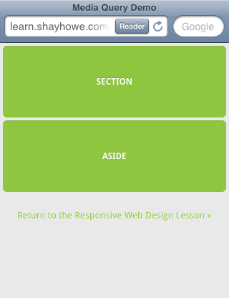
JavaScript
JavaScript is a very powerful client-side scripting language. JavaScript is used mainly for enhancing the interaction of a user with the webpage. In other words, you can make your webpage more lively and interactive, with the help of JavaScript. JavaScript is also being used widely in game development and Mobile application development.
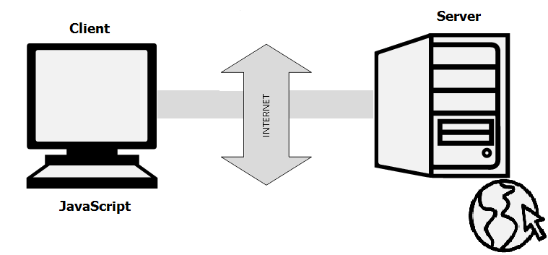
Being a scripting language, JavaScript cannot run on its own. In fact, the browser is responsible for running JavaScript code. When a user requests an HTML page with JavaScript in it, the script is sent to the browser and it is up to the browser to execute it. The main advantage of JavaScript is that all modern web browsers support JavaScript. So, you do not have to worry about whether your site visitor uses Internet Explorer, Google Chrome, Firefox or any other browser. JavaScript will be supported.
Project’s

Project-1 (Avi’s Juice Bar)

HTML CODE:
<!DOCTYPE html>
<html lang="en">
<head>
<meta charset="utf-8">
<meta name="viewport" content="width=device-width, initial-scale=1.0">
<link rel="stylesheet" media="screen" href="https://cdnjs.cloudflare.com/ajax/libs/twitter-bootstrap/3.3.5/css/bootstrap.min.css">
<link href="https://fonts.googleapis.com/css?family=Pinyon+Script" rel="stylesheet">
<link href="https://fonts.googleapis.com/css?family=Mr+Dafoe" rel="stylesheet">
<link rel="stylesheet" href="css/style.css">
<title>Avi's Juice Bar</title>
<!--https://www.pexels.com/photo/man-night-bar-barman-110472/-->
</head>
<body>
<div class="container center">
<div class="row">
<div class="col-md-12">
<h1>Avi's</h1>
<h2>Juice Bar</h2>
</div>
</div>
<div class="row">
<div class="col-md-12">
<form class="form-inline">
<div class="form-group">
<input type="text" class="form-control" id="exampleInputName2" placeholder="Your Name">
</div>
<div class="form-group">
<input type="email" class="form-control" id="exampleInputEmail2" placeholder="Your Email">
</div>
<button type="submit" class="btn btn-info">Send invitation</button>
</form>
</div>
</div>
</div>
<script src="https://cdnjs.cloudflare.com/ajax/libs/jquery/1.11.3/jquery.min.js"></script>
<scriptsrc="https://cdnjs.cloudflare.com/ajax/libs/twitter-bootstrap/3.3.5/js/bootstrap.min.js"></script>
</body>
</html>

CSS CODE:
html{
height: 100%;
}

body{
background: url(../images/customFruitBar.png);
background-position: center;
background-size: cover;
}
.center{
text-align: center;
padding-top: 15%;
}
h1{
font-family: 'Pinyon Script', cursive;
color: #fff;
font-size: 6em;
}
h2{
color: #fff;
font-size: 3em;
font-family: 'Mr Dafoe', cursive;
}

OUTPUT:

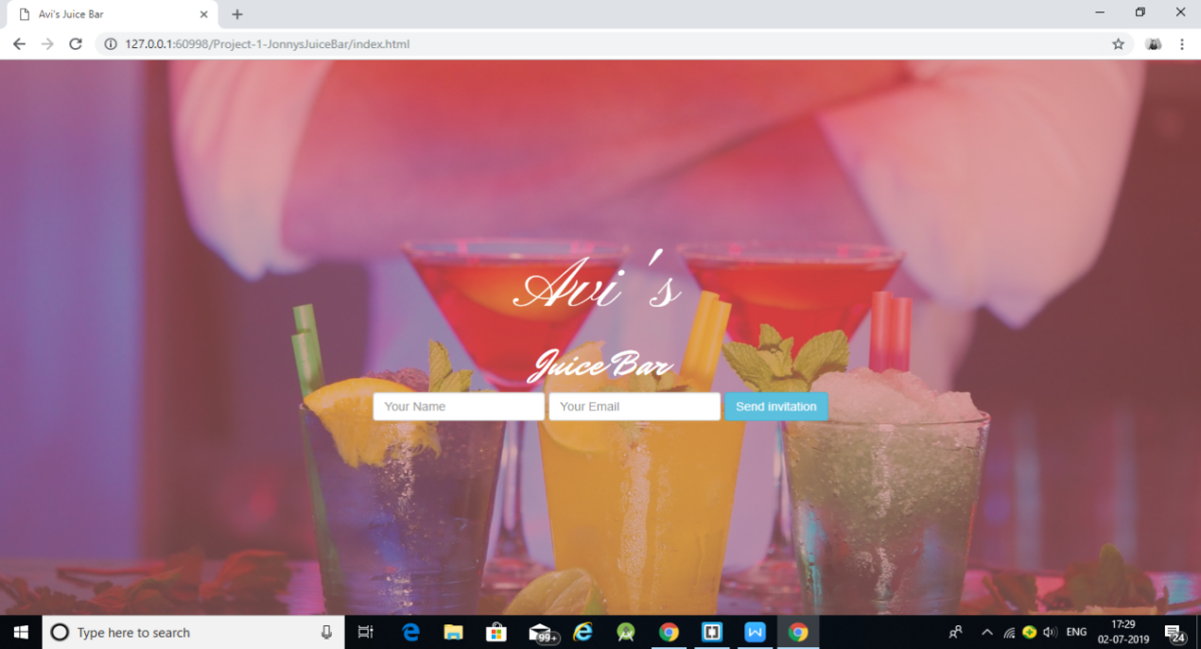

Project-2 (Feature-Comparision)

HTML CODE:
<!DOCTYPE html>
<html lang="en">
<head>
<meta charset="utf-8">
<meta name="viewport" content="width=device-width, initial-scale=1.0">
<link rel="stylesheet" media="screen" href="https://cdnjs.cloudflare.com/ajax/libs/twitter-bootstrap/3.3.5/css/bootstrap.min.css">
<link rel="stylesheet" href="https://maxcdn.bootstrapcdn.com/font-awesome/4.7.0/css/font-awesome.min.css">
<link href="https://fonts.googleapis.com/css?family=Droid+Serif" rel="stylesheet">
<link rel="stylesheet" href="css/style.css">
<title>Minimum Bootstrap HTML Skeleton</title>
</head>
<body>
<div class="container">
<div class="price">
<div class="container">
<h1>Our pricing and Features</h1>
<hr>
<div class="row">
<table class="table table-condensed">
<thead>
<tr>
<th class="col1">Features</th>
<th class="col2">Silver package 100$ </th>
<th class="col3">Gold package 200$</th>
<th class="col4">Diamond Package 400$</th>
</tr>
</thead>
<tbody>
<tr>
<td class="col1">Hosting on Linux</td>
<td class="col2"><i class="fa fa-times cross" aria-hidden="true"></i></td>
<td class="col3"><i class="fa fa-check right" aria-hidden="true"></i></td>
<td class="col4"><i class="fa fa-check right" aria-hidden="true"></i></td>
</tr>
<tr>
<td class="col1">Backup</td>
<td class="col2"><i class="fa fa-times" aria-hidden="true"></i></td>
<td class="col3"><i class="fa fa-check" aria-hidden="true"></i></td>
<td class="col4"><i class="fa fa-check" aria-hidden="true"></i></td>
</tr>
<tr>
<td class="col1">Maintaince</td>
<td class="col2"><i class="fa fa-times" aria-hidden="true"></i></td>
<td class="col3"><i class="fa fa-check" aria-hidden="true"></i></td>
<td class="col4"><i class="fa fa-check" aria-hidden="true"></i></td>
</tr>
<tr>
<td class="col1">Search Optimization</td>
<td class="col2"><i class="fa fa-times" aria-hidden="true"></i></td>
<td class="col3"><i class="fa fa-check" aria-hidden="true"></i></td>
<td class="col4"><i class="fa fa-check" aria-hidden="true"></i></td>
</tr>
<tr>
<td class="col1">Clean up</td>
<td class="col2"><i class="fa fa-times" aria-hidden="true"></i></td>
<td class="col3"><i class="fa fa-check" aria-hidden="true"></i></td>
<td class="col4"><i class="fa fa-check" aria-hidden="true"></i></td>
</tr>
<tr>
<td class="col1">Buy Plans</td>
<td class="col2"><button class="btn btn-success" type="submit">Buy Now !</button></td>
<td class="col3"><button class="btn btn-info" type="submit">Buy Now !</button></td>
<td class="col4"><button class="btn btn-danger" type="submit">Buy Now !</button></td>
</tr>
</tbody>
</table>
</div>
</div>
</div>

</div>
<script src="https://cdnjs.cloudflare.com/ajax/libs/jquery/1.11.3/jquery.min.js"></script>
<script src="https://cdnjs.cloudflare.com/ajax/libs/twitter-bootstrap/3.3.5/js/bootstrap.min.js"></script>
<script>
</script>
</body>
</html>

CSS CODE:
html{
height: 100%;
}
body{
background: url(../images/money.png);
background-position: center;
background-size: cover;
font-family: 'Droid Serif', serif;
}
.price h1{
font-size: 3em;
color: #fff;
text-transform: capitalize;
text-align: center;
}
.col1{
background: #fff;
width: 40%;
padding: 12px !important;
}
th.col1{
background: #fff;
text-transform: uppercase;
padding: 30px 10px !important;
font-size: 1.5em;
color: #000;
}
.col2{
background: #009677;
text-align: center;
color: #fff;

}
th.col2{
background: #00c854;
padding: 30px 10px !important;
font-size: 1.5em;
text-transform: uppercase;
}
.col3{
background: #03a9f4;
text-align: center;
color: #fff;
}
th.col3{
background: #039be5;
padding: 30px 10px !important;
font-size: 1.5em;
text-transform: uppercase;
}
.col4{
background: #ef5350;
text-align: center;
color: #fff;
}
th.col4{
background: #e53935;
padding: 30px 10px !important;
font-size: 1.5em;
text-transform: uppercase;
}
.right{
background: #8870FF;
padding: 6px;
border: 2px solid;
color: aliceblue;
}
.cross{
background: skyblue;
padding: 6px;
border: 2px solid;
color: aliceblue;
}
.btn{
border: 2px solid #fff;
}

OUTPUT:

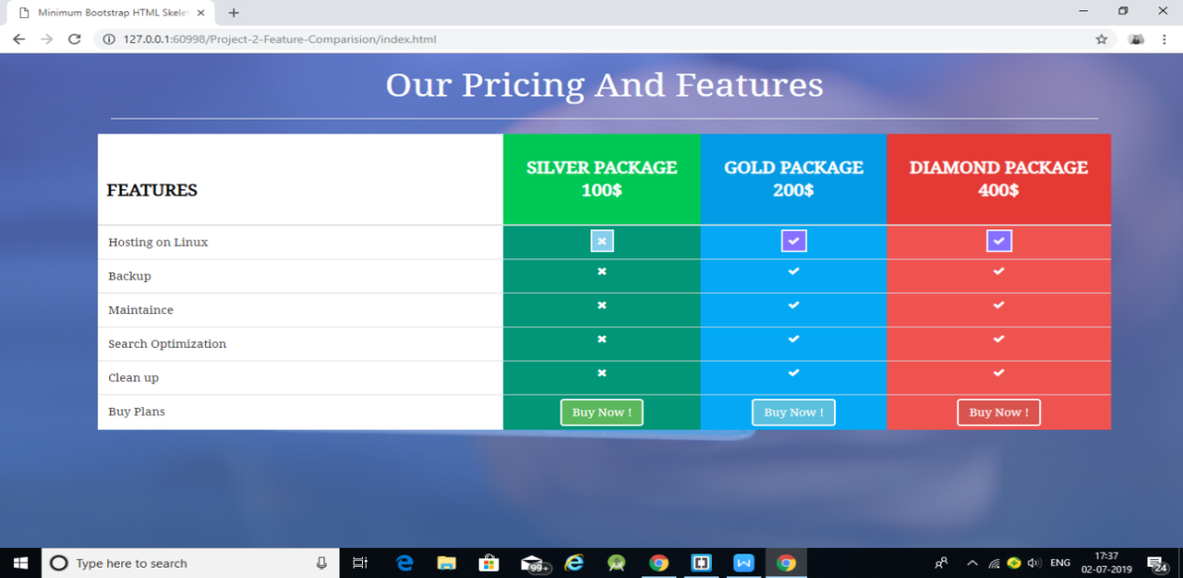
Project-3 (FB-Registration)

HTML CODE:
<!DOCTYPE html>
<html lang="en">
<head>
<meta charset="utf-8">
<meta name="viewport" content="width=device-width, initial-scale=1.0">
<link rel="stylesheet" media="screen" href="https://cdnjs.cloudflare.com/ajax/libs/twitter-bootstrap/3.3.5/css/bootstrap.min.css">
<link href="https://fonts.googleapis.com/css?family=Lora" rel="stylesheet">
<link rel="stylesheet" href="css/style.css">
<title>Offset tutorial</title>
</head>
<body>
<div class="container">
<div class="row">
<div class="col-xs-12 col-sm-8 col-md-6 col-sm-offset-2 col-md-offset-3 ">
<form action="" role="form">
<h1>Facebook <small>It's free and will always be</small> </h1>
<hr>
<div class="row">
<div class="col-xs-12 col-sm-6 col-md-6">
<div class="form-group">
<input type="text" placeholder="First Name" class="form-control input-lg">
</div>
</div>
<div class="col-xs-12 col-sm-6 col-md-6">
<div class="form-group">
<input type="text" placeholder="Last name" class="form-control input-lg">
</div>
</div>
</div>
<div class="form-group">
<input type="text" placeholder="Username" class="form-control input-lg">
</div>
<div class="form-group">
<input type="text" placeholder="Email" class="form-control input-lg">
</div>

<div class="row">
<div class="col-xs-12 col-sm-6 col-md-6">
<div class="form-group">
<input type="password" placeholder="password" class="form-control input-lg">
</div>
</div>
<div class="col-xs-12 col-sm-6 col-md-6">
<div class="form-group">
<input type="password" placeholder="Retype your password" class="form-control input-lg">
</div>
</div>
</div>
<div class="row">
<div class="col-xs-12">
<p>By clicking on Register, you agree with our terms</p>
</div>
</div>
<hr>
<div class="row">
<div class="btn btn-primary btn-lg btn-block">Register</div>
<div class="btn btn-success btn-lg btn-block">Log In</div>
</div>
</form>
</div>
</div>
</div>
<script src="https://cdnjs.cloudflare.com/ajax/libs/jquery/1.11.3/jquery.min.js"></script>
<script src="https://cdnjs.cloudflare.com/ajax/libs/twitter-bootstrap/3.3.5/js/bootstrap.min.js">
</script>
<script>
</script>
</body>
</html>

CSS CODE:
body{
font-family: 'Lora', serif;
background: #1e130c; /* fallback for old browsers */
background: -webkit-linear-gradient(to left, #1e130c , #9a8478); /* Chrome 10-25, Safari 5.1-6 */
background: linear-gradient(to left, #1e130c , #9a8478); /* W3C, IE 10+/ Edge, Firefox 16+, Chrome 26+, Opera 12+, Safari 7+ */
}
h1{
color: #fff;
}
h1 small{
color: azure;
}
p{
color: #fff;
}

OUTPUT:

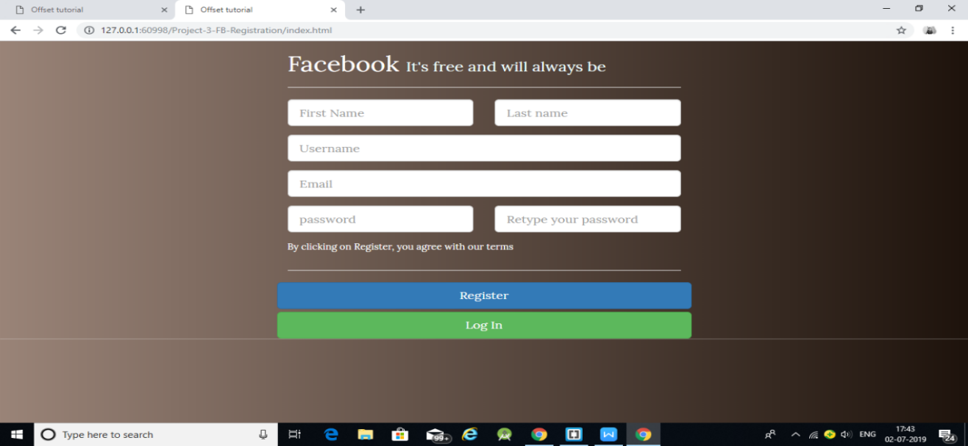

Project-4 (Ivan’s-Image)

HTML CODE:
<!DOCTYPE html>
<html lang="en">
<head>
<meta charset="utf-8">
<meta name="viewport" content="width=device-width, initial-scale=1.0">
<link rel="stylesheet" media="screen" href="https://cdnjs.cloudflare.com/ajax/libs/twitter-bootstrap/3.3.5/css/bootstrap.min.css">
<link rel="stylesheet" href="https://maxcdn.bootstrapcdn.com/font-awesome/4.7.0/css/font-awesome.min.css">
<link href="https://fonts.googleapis.com/css?family=Mogra" rel="stylesheet">
<link rel="stylesheet" href="css/style.css">
<title>Ivan's Image Gallery</title>

<!-- -->

<style>

</style>

</head>

<body>

<div class="container">
<nav class="navbar navbar-default">
<div class="container-fluid">
<!-- Brand and toggle get grouped for better mobile display -->
<div class="navbar-header">
<button type="button" class="navbar-toggle collapsed" data-toggle="collapse" data-target="#bs-example-navbar-collapse-1" aria-expanded="false">
<span class="sr-only">Toggle navigation</span>
<span class="icon-bar"></span>
<span class="icon-bar"></span>
<span class="icon-bar"></span>
</button>
<a class="navbar-brand" href="#">Ivan</a>
</div>

<!-- Collect the nav links, forms, and other content for toggling -->
<div class="collapse navbar-collapse" id="bs-example-navbar-collapse-1">
<ul class="nav navbar-nav">
<li class="active"><a href="#">Gallery<span class="sr-only">(current)</span></a></li>
<li><a href="#">Home</a></li>
<li><a href="#">About Us</a></li>
<li><a href="#">Services</a></li>

</ul>

<ul class="nav navbar-nav navbar-right">
<li><a href="#"><i class="fa fa-user-plus" aria-hidden="true"></i> Sign Up</a></li>
<li><a href="#"><i class="fa fa-user" aria-hidden="true"></i>
Login</a></li>

</ul>
</div><!-- /.navbar-collapse -->
</div><!-- /.container-fluid -->
</nav>

<div class="jumbotron">
<h1>Ivan's Image Gallery!</h1>
<p>...</p>
<p><a class="btn btn-primary btn-lg" href="#" role="button">Call Us now</a></p>
</div>

<div class="row">
<div class="col-lg-4 col-md-6 col-sm-6">
<div class="thumbnail">
<img src="https://images.pexels.com/photos/59628/pexels-photo-59628.jpeg?w=1260&h=750&auto=compress&cs=tinysrgb" alt="">
</div>
</div>
<div class="col-lg-4 col-md-6 col-sm-6">
<div class="thumbnail">
<img src="https://images.pexels.com/photos/109371/pexels-photo-109371.jpeg?w=1260&h=750&auto=compress&cs=tinysrgb" alt="">
</div>
</div>
<div class="col-lg-4 col-md-6 col-sm-6">
<div class="thumbnail">
<img src="https://images.pexels.com/photos/198285/pexels-photo-198285.jpeg?w=1260&h=750&auto=compress&cs=tinysrgb" alt="">
</div>
</div>
<div class="col-lg-4 col-md-6 col-sm-6">
<div class="thumbnail">
<img src="https://images.pexels.com/photos/59628/pexels-photo-59628.jpeg?w=1260&h=750&auto=compress&cs=tinysrgb" alt="">
</div>
</div>
<div class="col-lg-4 col-md-6 col-sm-6">
<div class="thumbnail">
<img src="https://images.pexels.com/photos/59628/pexels-photo-59628.jpeg?w=1260&h=750&auto=compress&cs=tinysrgb" alt="">
</div>
</div>
<div class="col-lg-4 col-md-6 col-sm-6">
<div class="thumbnail">
<img src="https://images.pexels.com/photos/59628/pexels-photo-59628.jpeg?w=1260&h=750&auto=compress&cs=tinysrgb" alt="">
</div>
</div>
</div>
</div>

<script src="https://cdnjs.cloudflare.com/ajax/libs/jquery/1.11.3/jquery.min.js"></script>
<script src="https://cdnjs.cloudflare.com/ajax/libs/twitter-bootstrap/3.3.5/js/bootstrap.min.js">
</script>
<script>
</script>
</body>
</html>

CSS CODE:
body{
background-color: #000;
}
.navbar{
background-color: #000;
color: white;
}
.navbar-default .navbar-nav>li>a{
color: #fff;
}
.navbar-default .navbar-nav>li>a:hover{
color: yellow;
}
.navbar-default .navbar-brand{
color: yellow;
}
.jumbotron{
background-color: #1d9e74;
color: white;
text-align: center;
font-family: 'Mogra', cursive;
}
.thumbnail{
width: 100%;
height: 200px;
overflow: hidden;
}
img{
width: auto;
height: auto;
}

OUTPUT:

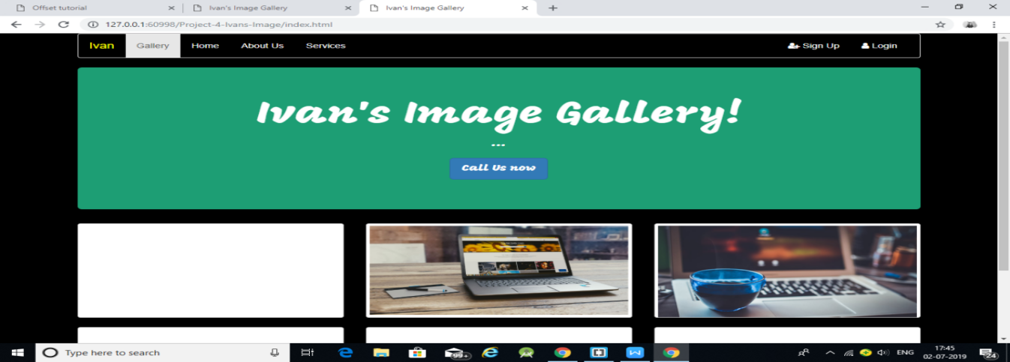
Project-5 (Login-Box)

HTML CODE:
<!DOCTYPE html>
<html lang="en">
<head>
<meta charset="utf-8">
<meta name="viewport" content="width=device-width, initial-scale=1.0">
<link rel="stylesheet" media="screen" href="https://cdnjs.cloudflare.com/ajax/libs/twitter-bootstrap/3.3.5/css/bootstrap.min.css">
<link href="https://fonts.googleapis.com/css?family=Raleway" rel="stylesheet">
<link rel="stylesheet" href="css/style.css">
<title>Login Panel for Special user</title>
</head>
<body>
<div class="container">
<div class="row login">
<div class="col-md-12 col-xs-12" align="center" >
<div class="line"><h3>12 : 34 PM</h3></div>
<div class="outter"><img class="image-circle" src="https://images.pexels.com/photos/35537/child-children-girl-happy.jpg?w=1260&h=750&auto=compress&cs=tinysrgb" alt="cute boy image"></div>
<h1>Hola Admin</h1>
<span>You are getting logged in from <strong>Spain</strong></span>
</div>
<div class="col-md-6 col-xs-6 ip" align="center">
<h3>CHROME <br> YOUR BROWSER</h3>
</div>
<div class="col-md-6 col-xs-6 ip" align="center">
<h3>192.168.1.1 <br> YOUR IP</h3>
</div>
<div class="col-md-12 col-xs-12 login_control">
<div class="control">
<div class="label">Email Address</div>
<input type="text" class="form-control" value="adam@facebook.com">

</div>
<div class="control">
<div class="label">Password</div>
<input type="password" class="form-control" value="12345">

</div>
<div align="center">
<button class="btn btn-custom">LOGIN</button>
</div>
</div>
</div>
</div>
<script src="https://cdnjs.cloudflare.com/ajax/libs/jquery/1.11.3/jquery.min.js"></script>
<script src="https://cdnjs.cloudflare.com/ajax/libs/twitter-bootstrap/3.3.5/js/bootstrap.min.js">
</script>
<script>
</script>
</body>
</html>

CSS CODE:
body{
background-color: #2b2b2b;
}

*{
font-family: 'Raleway', sans-serif;
color: #fff;
}
.login{
background-color: #2980b9;
width: 35%;
position: absolute;
top: 15%;
left: 5%;
}
.image-circle{
border-radius: 50%;
width: 200px;
height: 200px;
border: 4px solid #fff;
margin: 10px;
}
.ip{
background-color: #59a9c2;
height: 80px;
}
.ip:hover{
background-color: #2980b9;
height: 80px;
}
.login_control{
background-color: #fff;
padding: 15px;
}
.control{
color: #000;
}
.label{
color: #ed4f26;
font-size: 18px;
}
.form-control{
font-size: 25px;
padding: 25px;
border-bottom: 1px solid #ccc;
}
.btn-custom{
background-color: #2c82c9;
border-radius: 20px;
margin: 10px;
padding: 5px;
width: 150px;
font-size: 20px;
}
@media (max-width: 767px){
.login{
background-color: #16a085;
width: 90%;
position: absolute;
top: 10%;
left: 5%;
}
}

OUTPUT:

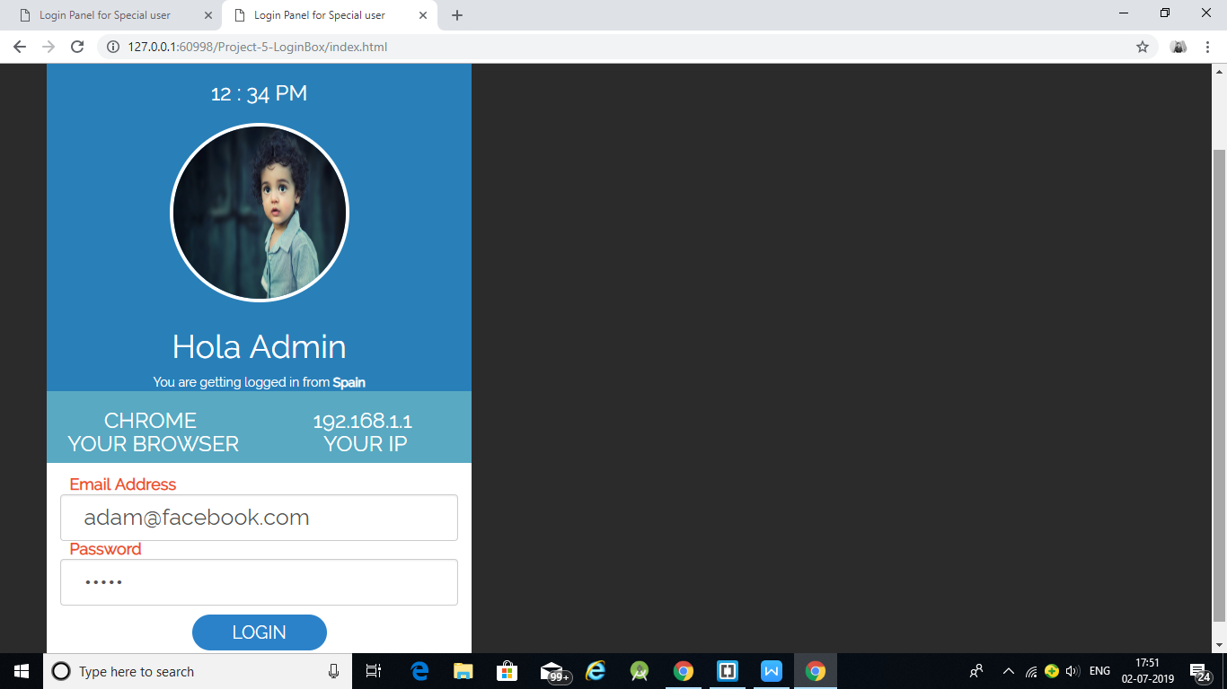

Project-6 (Course-Seller)

HTML CODE:
<!DOCTYPE html>
<html lang="en">
<head>
<meta charset="utf-8">
<meta name="viewport" content="width=device-width, initial-scale=1.0">
<link rel="stylesheet" media="screen" href="https://cdnjs.cloudflare.com/ajax/libs/twitter-bootstrap/3.3.5/css/bootstrap.min.css">

<!-- custom css goes here-->
<link rel="stylesheet" href="css/style.css">

<title>Course seller Page</title>
</head>

<body>
<nav class="navbar navbar-default">
<div class="container-fluid">
<!-- Brand and toggle get grouped for better mobile display -->
<div class="navbar-header">
<button type="button" class="navbar-toggle collapsed" data-toggle="collapse" data-target="#bs-example-navbar-collapse-1" aria-expanded="false">
<span class="sr-only">Toggle navigation</span>
<span class="icon-bar"></span>
<span class="icon-bar"></span>
<span class="icon-bar"></span>
</button>
<a class="navbar-brand" href="#">iOS 10 course</a>
</div>

<!-- Collect the nav links, forms, and other content for toggling -->
<div class="collapse navbar-collapse" id="bs-example-navbar-collapse-1">
<ul class="nav navbar-nav">
<li ><a href="#">Home<span class="sr-only">(current)</span></a></li>
<li><a href="#">Products</a></li>
<li><a href="#">Services</a></li>

</ul>

<ul class="nav navbar-nav navbar-right">
<li><a href="#">Log In</a></li>

</ul>
</div><!-- /.navbar-collapse -->
</div><!-- /.container-fluid -->
</nav>
<div class="container">
<div id="carousel-example-generic" class="carousel slide" data-ride="carousel">
<!-- Indicators -->
<ol class="carousel-indicators">
<li data-target="#carousel-example-generic" data-slide-to="0" class="active"></li>
<li data-target="#carousel-example-generic" data-slide-to="1"></li>
<li data-target="#carousel-example-generic" data-slide-to="2"></li>
<li data-target="#carousel-example-generic" data-slide-to="3"></li>
</ol>

<!-- Wrapper for slides -->
<div class="carousel-inner" role="listbox">
<div class="item active">
<img src="https://images.pexels.com/photos/4158/apple-iphone-smartphone-desk.jpg?w=1260&h=750&auto=compress&cs=tinysrgb" alt="...">

</div>
<div class="item">
<img src="https://images.pexels.com/photos/4159/coffee-cup-mug-apple.jpg?w=1260&h=750&auto=compress&cs=tinysrgb" alt="...">

</div>

<div class="item">
<img src="https://images.pexels.com/photos/164/man-person-apple-iphone.jpg?w=1260&h=750&auto=compress&cs=tinysrgb" alt="...">

</div>
<div class="item">
<imgsrc="https://images.pexels.com/photos/7111/couch-conference-startup-bro-
concentration.jpg?w=1260&h=750&auto=compress&cs=tinysrgb" alt="...">

</div>
</div>
<!-- Controls -->
<a class="left carousel-control" href="#carousel-example-generic" role="button" data-slide="prev">
<span class="glyphicon glyphicon-chevron-left" aria-hidden="true"></span>
<span class="sr-only">Previous</span>
</a>
<a class="right carousel-control" href="#carousel-example-generic" role="button" data-slide="next">
<span class="glyphicon glyphicon-chevron-right" aria-hidden="true"></span>
<span class="sr-only">Next</span>
</a>
</div>
<div class="row">
<div class="col-md-12 text-center">
<!-- trigger-->
<a href="#" class="btn btn-lg btn-danger" data-toggle="modal" data-target="#videoModal" data-theVideo="https://www.youtube.com/embed/peSXZi_nxek" > Have a look at promo</a>

<div class="modal fade" id="videoModal" tabindex="-1" role="dialog" aria-labelledby="myModalLabel">
<div class="modal-dialog" role="document">
<div class="modal-content">
<div class="modal-body">
<div>
<iframe width="100%" height="350" src="https://www.youtube.com/embed/peSXZi_nxek" allowfullscreen></iframe>
</div>

</div>
</div>
</div>
</div>

<button class="btn btn-success btn-lg">Buy iOS 10 Course</button>
</div>
</div>
</div>
<script src="https://cdnjs.cloudflare.com/ajax/libs/jquery/1.11.3/jquery.min.js"></script>
<scriptsrc="https://cdnjs.cloudflare.com/ajax/libs/twitter-bootstrap/3.3.5/js/bootstrap.min.js"></script>
<script>
</script>

</body>
</html>

CSS CODE:
.navbar-default{
background-color: chocolate;
}
.navbar-default .navbar-nav>li>a{
color: black;
}
.navbar-default .navbar-brand{
color: yellow;
}

body{
background: #603813; /* fallback for old browsers */
background: -webkit-linear-gradient(to left, #603813 , #b29f94); /* Chrome 10-25, Safari 5.1-6 */
background: linear-gradient(to left, #603813 , #b29f94); /* W3C, IE 10+/ Edge, Firefox 16+, Chrome 26+, Opera 12+, Safari 7+ */
}
.btn{
margin-top: 5%;
margin-bottom: 10%;
}

OUTPUT:

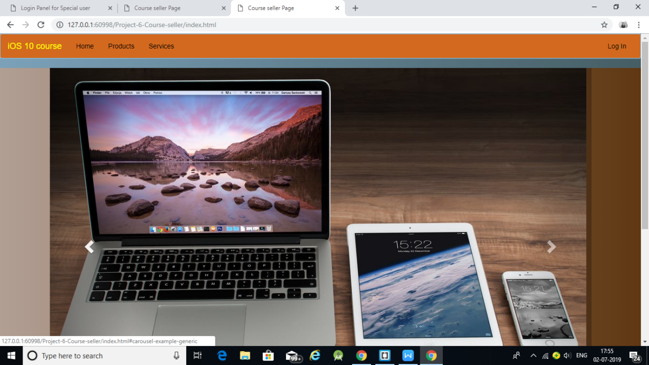

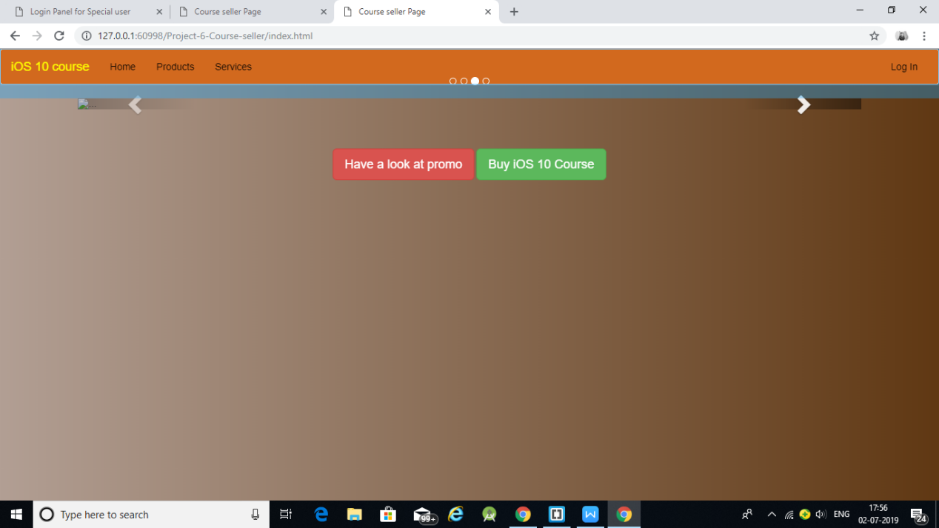

Project-7 (Complete-Web)

HTML CODE:
<!DOCTYPE html>
<html lang="en">
<head>
<meta charset="utf-8">
<meta name="viewport" content="width=device-width, initial-scale=1.0">
<link rel="stylesheet" media="screen" href="https://cdnjs.cloudflare.com/ajax/libs/twitter-bootstrap/3.3.5/css/bootstrap.min.css">
<link href="https://fonts.googleapis.com/css?family=Courgette" rel="stylesheet">

<link rel="stylesheet" href="css/customStyle.css">

<title>A site for Bootcamps</title>

<!-- -->

<style>

</style>

</head>

<body>

<!--++++++++++++++ Navigation Bar +++++++++++++-->
<div class="navbar-wrapper">
<div class="container">
<nav class="navbar navbar-inverse navbar-static-top">
<div class="container">
<div class="navbar-header">
<button type="button" class="navbar-toggle coolapsed" data-toggle="collapse" data-target="#navbar" aria-expanded="false" aria-controls="navbar" >
<span class="sr-only">Toggle Navigation</span>
<span class="icon-bar"></span>
<span class="icon-bar"></span>
<span class="icon-bar"></span>
</button>
<a href="#" class="navbar-brand">Online Bootcamp</a>
</div>
<div id="navbar" class="navbar-collapse collapse">
<ul class="nav navbar-nav">
<li><a href="#">Home</a></li>
<li><a href="#">About Bootcamps</a></li>
<li><a href="#">Contact Us</a></li>
<li class="dropdown">
<a href="#" class="dropdown-toggle" data-toggle="dropdown" role="button" aria-haspopup="true" aria-expanded="false">Courses <span class="caret"></span></a>
<ul class="dropdown-menu">
<li><a href="#">iOS 10</a></li>
<li><a href="#">Pentesting</a></li>
<li><a href="#">Front End Web Dev</a></li>
<li class="divider" role="separator"></li>
<li class="dropdown-header">Already Signed Up</li>
<li><a href="#">Track Progress</a></li>
<li><a href="#">Log In</a></li>
</ul>
</li>
</ul>
</div>

</div>
</nav>
</div>
</div>
<!--++++++++++++++ Navigation Bar Ends Here +++++++++++++-->

<!--++++++++++++++ Carousel +++++++++++++-->

<div id="myCarousel" class="carousel slide" data-ride="carousel">
<ol class="carousel-indicators">
<li data-target="#myCarousel" data-slide-to="0" class="active" ></li>
<li data-target="#myCarousel" data-slide-to="1" ></li>
<li data-target="#myCarousel" data-slide-to="2" ></li>
</ol>
<div class="carousel-inner" role="listbox">
<div class="item active">
<img class="first-slide" src="https://images.pexels.com/photos/39630/ipad-samsung-music-play-39630.jpeg?w=1260&h=750&auto=compress&cs=tinysrgb" alt=" First Image goes here">
<div class="container">
<div class="carousel-caption">

<h1>Best iOS course</h1>
<p>Learn iOS 10 Development with Firebase</p>
<p><a href="#" class="btn btn-lg btn-primary" role="button">Sign Up Today</a></p>
</div>
</div>
</div>

<div class="item">
<img class="second-slide" src="https://images.pexels.com/photos/199093/pexels-photo-199093.jpeg?w=1260&h=750&auto=compress&cs=tinysrgb" alt=" First Image goes here">
<div class="container">
<div class="carousel-caption">

<h1>Best iOS course</h1>
<p>Learn iOS 10 Development with Firebase</p>
<p><a href="#" class="btn btn-lg btn-primary" role="button">Sign Up Today</a></p>
</div>
</div>
</div>

<div class="item">
<img class="third-slide" src="https://images.pexels.com/photos/218577/pexels-photo-218577.jpeg?w=1260&h=750&auto=compress&cs=tinysrgb" alt=" First Image goes here">
<div class="container">
<div class="carousel-caption">
<h1>Best iOS course</h1>
<p>Learn iOS 10 Development with Firebase</p>
<p><a href="#" class="btn btn-lg btn-primary" role="button">Sign Up Today</a></p>
</div>
</div>
</div>
</div>

<!-- Controls -->
<a class="left carousel-control" href="#carousel-example-generic" role="button" data-slide="prev">
<span class="glyphicon glyphicon-chevron-left" aria-hidden="true"></span>
<span class="sr-only">Previous</span>
</a>
<a class="right carousel-control" href="#carousel-example-generic" role="button" data-slide="next">
<span class="glyphicon glyphicon-chevron-right" aria-hidden="true"></span>
<span class="sr-only">Next</span>
</a>
</div>

<!--++++++++++++++ Carousel Ends here +++++++++++++-->

<!--++++++++++++++ Marketing section starts here +++++++++++++-->
<div class="container marketing">

<div class="row">
<div class="col-md-4">
<img class="img-circle" src="https://images.pexels.com/photos/39630/ipad-samsung-music-play-39630.jpeg?w=1260&h=750&auto=compress&cs=tinysrgb" alt="marketing image" width="140" height="140">
<h2>Heading</h2>
<p>Lorem ipsum dolor sit amet, consectetur adipisicing elit. Assumenda voluptatibus veritatis sed beatae iusto recusandae obcaecati quia suscipit earum ea.</p>
<p><a href="#" class="btn btn-success" role="button">View Details</a></p>
</div>
<div class="col-md-4">
<img class="img-circle" src="https://images.pexels.com/photos/39630/ipad-samsung-music-play-39630.jpeg?w=1260&h=750&auto=compress&cs=tinysrgb" alt="marketing image" width="140" height="140">
<h2>Heading</h2>
<p>Lorem ipsum dolor sit amet, consectetur adipisicing elit. Assumenda voluptatibus veritatis sed beatae iusto recusandae obcaecati quia suscipit earum ea.</p>
<p><a href="#" class="btn btn-success" role="button">View Details</a></p>
</div>
<div class="col-md-4">
<img class="img-circle" src="https://images.pexels.com/photos/39630/ipad-samsung-music-play-39630.jpeg?w=1260&h=750&auto=compress&cs=tinysrgb" alt="marketing image" width="140" height="140">
<h2>Heading</h2>
<p>Lorem ipsum dolor sit amet, consectetur adipisicing elit. Assumenda voluptatibus veritatis sed beatae iusto recusandae obcaecati quia suscipit earum ea.</p>
<p><a href="#" class="btn btn-success" role="button">View Details</a></p>
</div>
</div>

</div>
<!--++++++++++++++ Marketing section ends here +++++++++++++-->

<hr class="feature-divider">

<!--++++++++++++++ Feature section starts here +++++++++++++-->

<div class="row feature">
<div class="col-md-7">
<h2>Lorem ipsum dolor sit.</h2>
<p>Lorem ipsum dolor sit amet, consectetur adipisicing elit. Ullam, illo est officiis. Aliquid iusto atque cum. Similique quo quasi, iusto.Lorem ipsum dolor sit amet, consectetur adipisicing elit. Ullam, illo est officiis. Aliquid iusto atque cum. Similique quo quasi, iusto.Lorem ipsum dolor sit amet, consectetur adipisicing elit. Ullam, illo est officiis. Aliquid iusto atque cum. Similique quo quasi, iusto.Lorem ipsum dolor sit amet, consectetur adipisicing elit. Ullam, illo est officiis. Aliquid iusto atque cum. Similique quo quasi, iusto.</p>
</div>
<div class="col-md-5">
<img class="img-responsive center-block feature-image" src="https://images.pexels.com/photos/39630/ipad-samsung-music-play-39630.jpeg?w=1260&h=750&auto=compress&cs=tinysrgb" alt="">
</div>
</div>
<hr class="feature-divider">

<div class="row feature">

<div class="col-md-5">
<img class="img-responsive center-block feature-image" src="https://images.pexels.com/photos/39630/ipad-samsung-music-play-39630.jpeg?w=1260&h=750&auto=compress&cs=tinysrgb" alt="">
</div>
<div class="col-md-7">
<h2>Lorem ipsum dolor sit.</h2>
<p>Lorem ipsum dolor sit amet, consectetur adipisicing elit. Ullam, illo est officiis. Aliquid iusto atque cum. Similique quo quasi, iusto.Lorem ipsum dolor sit amet, consectetur adipisicing elit. Ullam, illo est officiis. Aliquid iusto atque cum. Similique quo quasi, iusto.Lorem ipsum dolor sit amet, consectetur adipisicing elit. Ullam, illo est officiis. Aliquid iusto atque cum. Similique quo quasi, iusto.Lorem ipsum dolor sit amet, consectetur adipisicing elit. Ullam, illo est officiis. Aliquid iusto atque cum. Similique quo quasi, iusto.</p>
</div>
</div>
<hr class="feature-divider">

<div class="row feature">
<div class="col-md-7">
<h2>Lorem ipsum dolor sit.</h2>
<p>Lorem ipsum dolor sit amet, consectetur adipisicing elit. Ullam, illo est officiis. Aliquid iusto atque cum. Similique quo quasi, iusto.Lorem ipsum dolor sit amet, consectetur adipisicing elit. Ullam, illo est officiis. Aliquid iusto atque cum. Similique quo quasi, iusto.Lorem ipsum dolor sit amet, consectetur adipisicing elit. Ullam, illo est officiis. Aliquid iusto atque cum. Similique quo quasi, iusto.Lorem ipsum dolor sit amet, consectetur adipisicing elit. Ullam, illo est officiis. Aliquid iusto atque cum. Similique quo quasi, iusto.</p>
</div>
<div class="col-md-5">
<img class="img-responsive center-block feature-image" src="https://images.pexels.com/photos/39630/ipad-samsung-music-play-39630.jpeg?w=1260&h=750&auto=compress&cs=tinysrgb" alt="">
</div>
</div>
<footer>
<p class="pull-right">Terms and Conditions apply</p>
</footer>
<script src="https://cdnjs.cloudflare.com/ajax/libs/jquery/1.11.3/jquery.min.js"></script>
<scriptsrc="https://cdnjs.cloudflare.com/ajax/libs/twitter-bootstrap/3.3.5/js/bootstrap.min.js"></script>
<script>
</script>
</body>
</html>

CSS CODE:
body{
background: #f46b45; /* fallback for old browsers */
background: -webkit-linear-gradient(to left, #f46b45 , #eea849); /* Chrome 10-25, Safari 5.1-6 */
background: linear-gradient(to left, #f46b45 , #eea849); /* W3C, IE 10+/ Edge, Firefox 16+, Chrome 26+, Opera 12+, Safari 7+ */

font-family: 'Courgette', cursive;

}
.navbar-wrapper{
position: absolute;
top: 0;
right: 0;
left: 0;
z-index: 20;
}
.carousel{
height: 500px;
margin-bottom: 60px;
}
.carousel .item{
height: 500px;
}
.carousel-inner > .item > img{
position: absolute;
height: 500px;
top: 0;
left: 0;
min-width: 100%;
}
.marketing{
text-align: center;
margin-bottom: 20px;
}
.feature-divider{
margin: 100px 20px;
}
.feature{
margin: 50px;
padding: 50px;
}
.feature p {
font-size: 22px;
color: dimgrey;
}

OUTPUT:

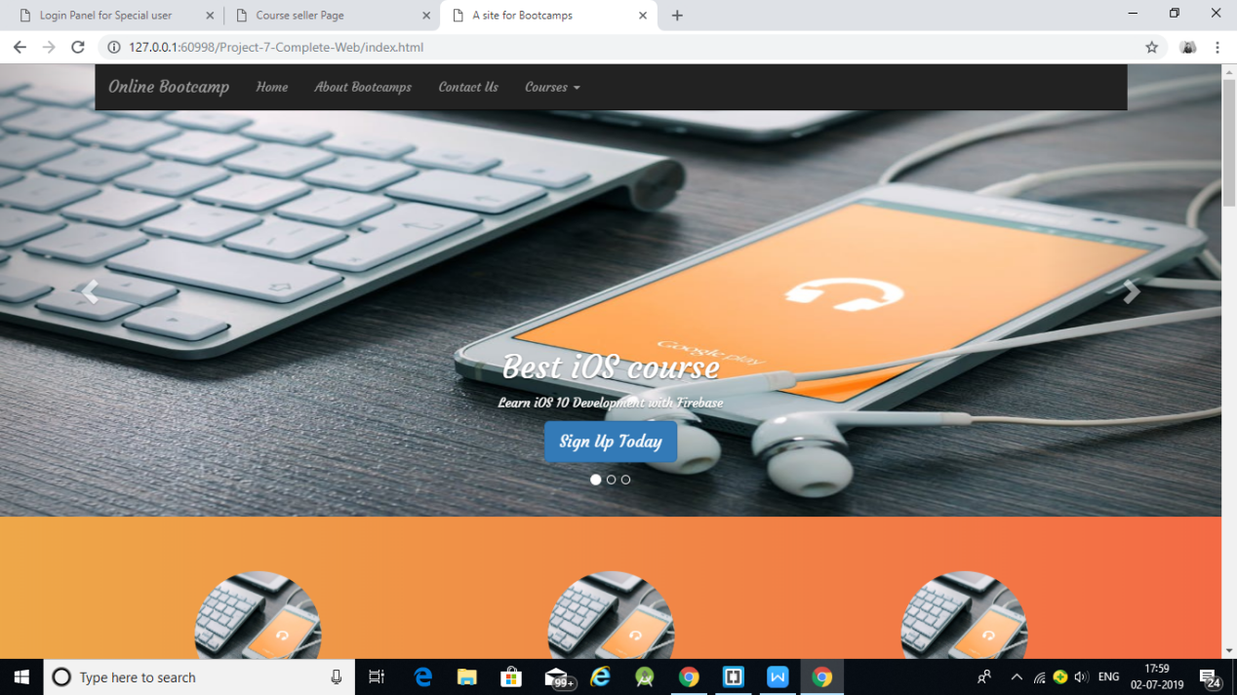

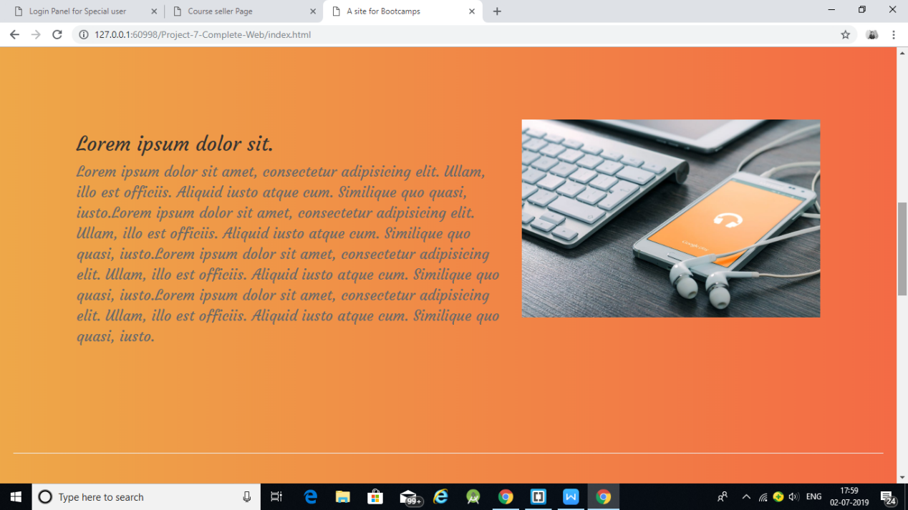

Pros of responsive web design
User-friendly – One website, many devices. One of the most appealing aspects of responsive web design is that a responsive website can provide a great user-experience across many devices and screen sizes. A fully functional and flexible website will improve the user experience and attract visitors to stay on the website. For example, if a customer finds a product on his smartphone he doesn’t need to go home and continue researching this product on the main site with different navigation but he can return on the same page he visited via his smartphone. Responsive web design has a positive user experience and customers can have access to all the information and content.
Google recommends – This is because responsive design sites have one URL and the same HTML, regardless of device, which makes it easier and more effective for Google to crawl, index, and organize content. It may mean that Google will start to consider this as a factor when ranking websites in near future.
One SEO and statistics – Mobile web requires a separate SEO management, which makes tracking statistics more complicated. Responsive web design has one URL and content, which means that the mobile “version” does not require a separate optimization. One URL address means that it is easier to do analytics, monitor and evaluate the SEO. But for getting insights on mobile visitors only you can create a “mobile-only” segment.

Why responsive web design is good for your SEO strategy:
Usability – Google wants to offer users what they search for. When potential customer navigates to your site and immediately returns to search engine results pages, Google makes a note that your site might not be the best choice for that search term. Your bounce rate (more about bounce rate) increases but ranking drops – i.e. homepage reputation will be damaged. With a responsive web design, visitors will get all the content they want, in a format they can read.
Duplicate content – It’s not bad for Google, if the mobile content is the same as in the website. But you’ll still have the same content on two places on the web, which is bothersome for content manager and could bring visitors to the wrong version of website. A responsively-designed website means that it has only one URL and visitors cannot accidentally get into mobile website version, or vice versa.
Ranking for mobile searches – Google has said that it ranks sites optimized for mobile higher in mobile searches. Google recommends responsive web design, meaning responsive designed sites will rank as well on mobile search as a site designed specifically for mobile.

Cons of Responsive Web Design
Loading time – With responsive web design mobile users will be downloading unnecessary HTML/CSS codes, which is not the main problem. The negative side is the long page loading time. Mobiles users usually expect fast service, but the mobile internet is slower and cannot cope with massive websites
Development -Developing responsive web design requires a lot of time from developers and web designers. Both must first learn a completely new and innovative concept. It’s easier and faster to create responsive web design from scratch.
Large pages – If a website has a lot of important content, responsive design means that all of that content has to be loaded on mobile pages. Opening time of a page like this is already longer and definitely not a convenient solution for users. If a web page has a lot of content and many different functions, it would be wiser to separate mobile and desktop versions.
Easy to find – As mobile users expect quick service and they are looking for specific information (e.g. address of the restaurant), it is not best solution to go with responsive web design. Use separate mobile web instead and add only content, that is most important for the visitor. No need to add you accountant hobbies, just contact information works fine.
Content management – Developing responsive website is more difficult than making changes on a mobile web. You need to contact with technical team to recode pictures and other things for responsive web design requirements.

Conclusion
Responsive web design is certainly a convenient solution for various types of websites. It is indeed a lot of work when it comes to development. But if your website is simple, logical, and has a lot of information that cannot be modified for mobile users – this is the right choice. First, set your website goals for both mobile and desktop version. Only with clear purpose you can make a decision whether to go for a responsive web design or separate mobile web.

